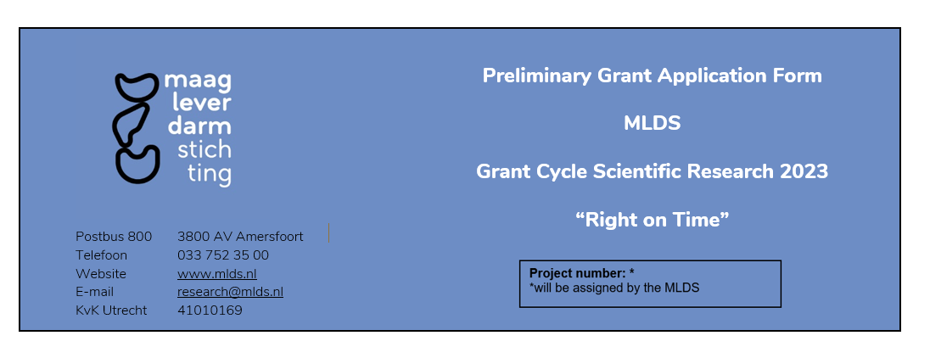
Please refer to the ‘Manual Preliminary Grant Application 2023’ for instructions.

Algemene informatie

1 | Institute
 | Department
 | Project Leader | First name, last name and title(s); Mr./ Mrs. ………………………………………  Please specify your position at the apply institute ……………………………………………………………………………………………………………………….  Do you have a permanent position? If not, when does your contract ends?..........................................................................................................................
 | Address
 | Telephone
 | E-mail
2 | Project group | Name, academic title Discipline Employed by Time spent on this project (% fte)
3 | Type of research | Clinical  Fundamental  Translational
4 | Theme of research | Esophageal cancer  Colon cancer  Unexplained digestive issues  Gut microbiome  Further development and/or implementation of promising project results on one of the above four themes, from research already funded by the MLDS in the context of early detection. Previous project code……..
5 | Budget | Personal type Equipment type  Total costs personnel Total costs equipment
 | Total project costs
 | Total project costs requested from MLDS
 | Total project costs requested from other party
Has this grant proposal been submitted or will this proposal be submitted to another funding organization?
No
Yes, namely to……………………………………………… for an amount of €……………………………..
Will part of the budget be covered by another organization?
No
Yes, namely to…………………………………………….for an amount of €………………………………….
6 | Signatures
 | Project leader Date (dd/mm/yyyy)
Name:
Signature:

 | Participants of project group
Name: Name:
Signature: Signature:

Name: Name:
Signature: Signature:

Name: Name:
Signature: Signature:

Name: Name:
Signature: Signature:

 | Head of department/ institute Date (dd/mm/yyyy)
Name:
Function:
Signature:

Project summary (English, max 1000 words)
Do not exceed the maximum of 1000 words excluding five relevant publications.

7 | Title | English:  Dutch:
8 | Background
9 | Hypothesis
10 | Objective
11 | Methods
11.1 | Research design:
11.2 | Subjects (if applicable) | Human  Animal  N.A.
Healthy subjects (number):
Patients (patient description and number):

 |  | Animal species (description and numbers):
11.3 | Samples (if applicable) | Origin:  Type:  Amount:  Availability:
11.4 | Analysis | Methods:  Machine/software:
11.5 | Work plan including timeframe and milestones
17 | Anticipated results
18 | Five relevant publications concerning this application | 1)  2)  3)  4)  5)

Appendix A. International experts
A. | List three international experts that should be able to review your project, without a Conflict of Interest | Name
 |  | Institute
 |  | Specialties
 |  | E-mail
 |  | Name
 |  | Institute
 |  | Specialties
 |  | E-mail
 |  | Name
 |  | Institute
 |  | Specialties
 |  | E-mail

